synchronous control method for Personal Rapid TRANSIT SYSTEMS

Christos Xithalis

ABSTRACT. Personal Rapid Transit (PRT) is an innovative urban transportation system which provides very fast transportation and adequate capacity. There are mainly 2 control alternatives for PRT systems: asynchronous and synchronous control. Asynchronous Control is a conceptually simpler method but imposes serious restrictions on network design and may lead to congestion when usage is high. On the other hand, most researchers find synchronous control inflexible, with capacity problems, and difficult to implement, especially in case of emergency. In this paper we will present a synchronous control scheme which doesn't exhibit the above problems and verify this claim with detailed simulation. We will show that synchronous control is a better choice than asynchronous control for a PRT system.

Description of a PRT system

PRT uses small automated fixed-rail electric vehicles running on a network of elevated guideways. These vehicles provide taxi service between offline stations and travel with almost constant speed, without any stops, free of congestion thanks to the special control method employed.

A PRT station is depicted in Figure 1. Vehicles on the main guideway travel at a steady speed. A vehicle wishing to stop at a station decelerates at a special offline guideway. Passengers embark or disembark at a platform. After that the vehicle accelerates at a special offline guideway and gets on the main network.

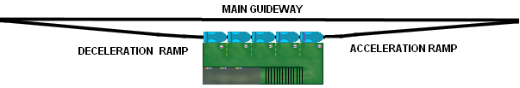
Figure 1. A typical PRT station with 5 berths

Station platforms may have various sizes, and can serve from 4-20 vehicles simultaneously. A PRT network, as seen in Figure 2, has many stations, and also many merge and diverge points, called nodes.

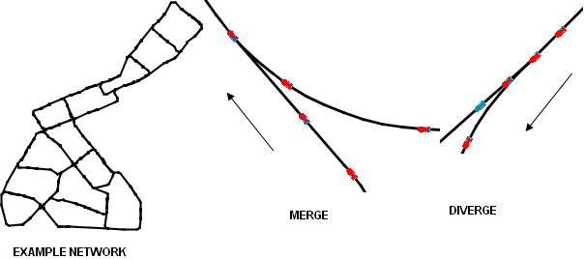
Figure 2. PRT network, merging and diverging nodes

control system TASKS

The main task of the control system is to ensure safety when vehicles move on the main guideway, i.e. all vehicles must keep a minimum separation distance, especially on merge points. The system must avert the forming of queues on the network (i.e. congestion). It must also ensure that vehicles arrive at stations at an acceptable rate. For example, the arrival of 15 vehicles in less than 20 seconds at a 5-berth station is not desirable since some of them will not be able to enter the station (wave-off vehicles). To do that, the system issues orders for vehicles to perform maneuvers.

Synchronous Control

In synchronous control each vehicle occupies a portion of the guideway called a slot, as depicted in figure 3.

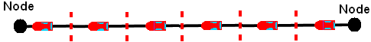
Figure 3. Synchronous control slots

A slot's size is defined as:

$\text{slotSize}=\text{speed}×\text{headway}$ (1)
where:

slotSize: the length of the slot
speed: the speed of the vehicles running on the main guideway
headway: minimum time between the consecutive passing of 2 vehicles

A slot needs <headway> seconds to pass through a node. Each node stores in a table which slots are already reserved by vehicles and which are free. Let’s assume that a vehicle must go from station A to station B passing through some nodes. The central controller computes the exact time the vehicle needs to get to its destination and also when it is going to be at each node (i.e. at which slots). If station B is not expected to be saturated at the time of arrival and if all the respective slots are free, they are marked as occupied and the vehicle departs. Following the set of required maneuvers (clear path) is the responsibility of the vehicle's redundant onboard computer.

Early PRT control research focused on synchronous control, Irving (1978). However it soon fell out of favor for the reasons discussed below.

Asynchronous Control

A vehicle doesn't wait for a clear path but enters the guideway as soon as possible without checking whether the other lines, further down its path, can handle the traffic. When vehicles get close to a diverge or merge point they communicate with a wayside controller. The controller issues the correct orders so that vehicles make the correct turn or merge safely. Vehicles perform maneuvers depending on traffic and the exact duration of their trip is not known in advance. This scheme, depicted in Figure 4, is similar to how cars move on a highway. Asynchronous control is described in more detail in Anderson (1998).

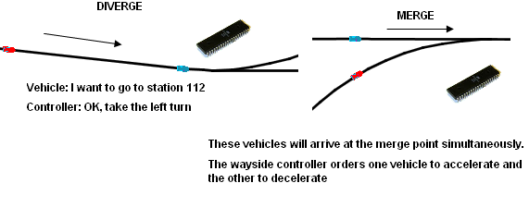
Figure 4. Asynchronous control
Comparison of control types

Advantages of Asynchronous Control

Conceptual Simplicity

The main advantage of asynchronous control is its conceptual simplicity and its robustness in case of anomalies (Irving 1978; Anderson 1998; Szillat 2001) Wayside controllers at each merge/diverge point work independently. A problem on the network can be handled very easily: the wayside controller upstream to the problem will divert traffic away from the blocked line, as depicted in Figure 5.

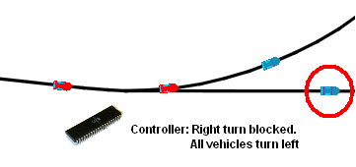
Figure 5. Asynchronous control response to stopped vehicle

Disadvantages of asynchronous control

Non Deterministic Flow

The main problem is that since the exact time a vehicle will arrive at each node is not known in advance, vehicles may reach nodes in inconvenient patterns, as depicted in Figure 6. Lines before merge points must be long enough to accommodate quite long maneuvers without violating any passenger comfort criteria. Some researchers propose that all lines must be long enough to allow vehicles stopping, Choi et al. (2005), or even queuing and reaccelerating to normal speed before reaching the merge point. This poses serious limitations to network topology and of course may lead to congestion just like in the road system. Vehicles may also arrive at stations in large groups, leading to an increased number of wave-off vehicles.

Figure 6. Groups of closely spaced vehicles arriving at a merging point

To decrease the possibility of such events, researchers propose to limit the rate of vehicles entering each portion of the network to a value well below the theoretical maximum capacity. Although the frequency of such events is decreased at the cost of overall capacity this way, totally congestion-free operation is not guaranteed.
Real-time Critical

In asynchronous control, real-time communication is critical: for example assume a vehicle is reaching a diverge node. It asks the wayside controller which turn to take and expects an answer. If for some reason the answer is delayed, the vehicle may take the wrong turn and collide with another vehicle. Modern electronic communication is reliable and fast but since PRT systems rely on wireless communication, some delays will probably occur. With asynchronous control, in a big network there may be tens of millions of such time critical communications each day. Possible delays, even at a rate of one in a million, are a serious problem.

Advantages of Synchronous Control

Not Real-time Critical

In synchronous control a vehicle won't start moving before a clear path is found. If a vehicle requests a clear path and it is delivered to it with a delay, it can easily reject it as late and request a new one.

Guaranteed Congestion-free and More Energy Efficient Operation

Since every vehicle has its own clear path, it is guaranteed to reach its destination running with almost constant speed (Szillat 2001; Xithalis 2007). Steady speed also helps to slightly reduce energy consumption.

Claimed Disadvantages of Synchronous Control

Inflexibility

In synchronous control each line (i.e. the guideway segment between 2 nodes) must be comprised of an integral number of slots. For example in the simulated system slot size is 5.4 meters ($=\text{18}×0\text{.}3$) and every line must be exactly i×5.4 meters (i is an integer). This simplifies routing calculations greatly. Asynchronous control supporters claim that this is very restrictive and inflexible, Szillat (2001).

However this is not the case: if the line is long enough, it is easy to 'absorb' any excess fractional slots: e.g. a line is 272.7 meters long. It has 50 slots + 2.7 meters (= 0.5 slot, worst case scenario) of extra guideway. A vehicle needs 15 seconds to traverse it. In these 15 seconds it must accelerate to cover the additional 2.7 meters and then decelerate to leave the line at the normal speed. A steady acceleration/deceleration of 0.05 m/sec² is enough. It clearly does not violate any passenger comfort criteria.

If the line is short we can "move" its starting or ending node a few meters so that it will be the right length as shown in Figure 7. Note that, from the central router's perspective a merge point doesn't have to coincide exactly with the guideway's structural merge point. Besides, the structural merge section has a considerable length whereas the routing merge point is a mathematical point. We can also extend this method and apply it to many consecutive short lines.
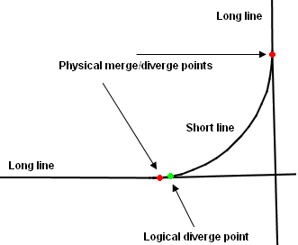
Figure 7. A logical diverge point might differ slightly from the physical diverge point

Reduced Capacity

It is stated, (Irving 1978; Anderson 1996), that a PRT network implementing synchronous control will meet with difficulty in routing vehicles and will face capacity problems. This is best illustrated with an example:

Let's assume that there is considerable traffic with line usage in the range of 50%, i.e. in each node about half of the slots are occupied by already moving vehicles. A vehicle needs to go to a station about 10 km away. It will pass through about 20 nodes. The central controller will construct a path and check if all nodes are available at the right time. There is 50% probability that the first node will be free, 50% for the second node, 50% for the third etc. The probability that all nodes are free at the right time is about (0.5)²⁰ = 10⁻⁶. The vehicle, even when traffic is at a modest 50%, will have to wait about 10⁶ slots before it gets a clear path. Therefore synchronous control can't even get close to capacities of about 50%.

However the logic exhibited above is flawed. Synchronous control critics omit or underestimate 4 important factors that alleviate the problem:

1) In synchronous control vehicles may move forward/backward an entire slot, if a line segment is long enough (in simulation, a vehicle can move backwards only a single slot if the line is long enough). This enhances the router's flexibility to find clear paths.

2) In a PRT network vehicles on occupied slots move at a steady speed. The empty slots between them also move at a steady speed, which means that once an empty slot is found chances are that the same slot will be available at the next node. In the above example chances of finding an empty slot are substantially higher than 50%. Formally speaking, the probabilities in the above calculation are not independent.

3) There may be more than one possible routes with similar length.

4) Occupied slots are not evenly distributed in time.

We will clarify that with an example: let's assume that there are many vehicles running on the network. Some of them just started a long trip and they have many slot reservations, spreading evenly from the present to about 20 minutes in the future. Some of them are in the middle of their trip and there are only a few slot reservations for them within the next 5-10 minutes. Some are near their destination and occupy a very small number of slots, only for the next few minutes. Occupied slot distribution versus time is presented in Figure 8. While about 60% of the slots are occupied now and in the immediate future, the percentage drops with time. The central router will only meet with difficulty in getting a clear path through the first few nodes, after that it will easily find empty slots.

Figure 8. Example of Percentage of Occupied Slots at Nodes vs. Time

Simulation, Xithalis (2007), proves that routing with synchronous control is very efficient, reaching a high percentage of line usage. Line throughput in the range of 10.500-11.000 vehicles/hour or more when maximum theoretical capacity is 12.000 vehicles/hour has been repeatedly observed.

Computationally Demanding

Another alleged problem for synchronous control is that too much work is done in the central controller. Calculating clear paths for a big network with hundreds of stations and thousands of vehicles is beyond the capabilities of a single computer, therefore a distributed approach, i.e. asynchronous control, should be preferred (Irving 1978; Choi et al. 2005; Szillat 2001).

The reasoning goes as such: for a big metropolitan network with e.g. 1000 stations there are about 5000 nodes. The fastest algorithm to find a shortest path requires O(NlogN) steps, that is about 60000 steps (N=5000). Then we’ll have to iterate over this path many times (perhaps thousands of times as claimed above) until we find a clear path free of conflicts. Calculating alternative routes may multiply that by a factor in the range of 1-100. Adding the flexibility of slip-back can increase the number of required steps further. Yet, in a big network there will be as many as 100 requests for clear paths per second. This is beyond the capabilities of a single computer to handle.

However, advances in computational power have been dramatic in the last few years. This, combined with an array of programming techniques, can solve the problem. The Hermes PRT simulator uses the following techniques (detailed explanation of these algorithms is lengthy and beyond the scope of this document):

1) Distances between nodes are precomputed - there is no need to run a 60000 step algorithm each time a new clear path is required. Finding a shortest path costs only about 10-100 steps.

2) The controller uses heavily optimized bit-level code to scan for clear paths in batches of 64: each step considers not 1 but 64 possible clear paths.

3) Alternate routes and slip-back flexibility are incorporated in the main algorithm - only one pass is required whereas the obvious approach would require several thousands passes to check all possible combinations of routes and/or vehicle maneuvers.

The net result is that the simulator is able to find clear path routes very efficiently. Running on a simple PC it is able to find several thousand clear paths per second. We should also note that in simulation the CPU is performing other tasks as well, such as simulating station operations, whereas in a real system there will be a dedicated server for that job alone.

Bad Behavior in Case of Emergency

It has been claimed that synchronous control meets with big difficulties in handling even relatively simple malfunctions, (Anderson 1998; Szillat 2001). If a vehicle stops for some reason on the main guideway, following vehicles will not be able to follow their assigned clear path and will have to stop. The growing queue will soon reach upstream lines blocking them too and creating a big gridlock which will soon expand to the entire network. Rerouting all affected vehicles is extremely hard, or even impossible due to blocked lines. Even if it is possible, all these computations will take too long and orders won’t be issued on time.

Once again, however, careful analysis and step by step approach provide satisfactory solutions, verified by detailed simulation. In the case of a stopped vehicle the simulator will:

1) Identify problematic lines, i.e. lines on which at least 1 vehicle slows down or stops.

2) Try to reroute vehicles that were scheduled to pass through them - if rerouting is not possible these vehicles stop in line.

3) Repeat until all vehicles scheduled to go through problematic lines either stop or get rerouted.

Figure 9 shows various vehicles and related actions. Simulation confirms that in most cases only a small fraction of the network and vehicles will be affected.

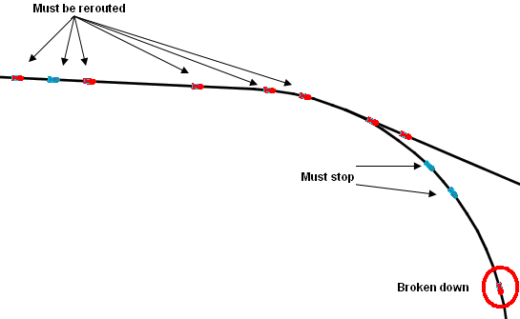
Figure 9. Emergency stopping and rerouting

Conclusions

Synchronous control for PRT systems offers significant advantages over asynchronous control: high capacity, congestion-free operation, less topology limitations for the PRT network and communications that are not real-time critical. Although it has been accused of a variety of disadvantages such as inflexibility, reduced capacity, being too demanding on the central controller and exhibiting bad response to emergencies, these problems are clearly not intrinsic to the concept and there exist appropriate solutions for each. Detailed simulation proves its practicality and future PRT system designers should seriously consider it as an alternative to asynchronous control.

References

Anderson, Edward (1996). “Synchronous or Clear-Path Control in Personal Rapid Transit Systems”, http://www.prtnz.com/component/option,com_docman/task,doc_download/gid,22/
(1998). “Control of Personal Rapid Transit Systems”, http://www.prtnz.com/component/option,com_docman/task,doc_download/gid,5/
Choi, Kyuwoong and Lee, Jin (2005). “High-Level Vehicle Control Algorithms For PRT (Personal Rapid Transit) System”, http://www.vectusprt.com/eng/data/down.asp?fn=PRT_veh_ctrl_algorithm.pdf
Irving, Jack (1978). “Fundamentals of Personal Rapid Transit”, ISBN: 0-669-02520-8
Szillat, Markus Theodor (2001). “A Low-level PRT Microsimulation”, http://www.mtsprt.homestead.com/files/thesis.pdf
Xithalis, Christos (2007). Hermes PRT network simulator http://students.ceid.upatras.gr/~xithalis/simulation_en.html

? Computer engineer, MSc in embedded electronics, e-mail: xithalis@gmail.com

